

Connecting to XenDesktop VDI via ICA client from External Internet Remote Office CAP Portal
(If you’re using a MAC, please follow the instructions in - Accessing the CAP from your MAC Quick Guide.PDF. This guide is intended for windows users only.)
- Prepare your computer
  - Add Remote Office to your Trusted Sites: Launch Internet Explorer, Select “Tools” > “Internet Options” > Security Tab > “ TrustedSites” > “Select Sites” > Add https://*.citigroup.com to the trusted site list
  - Add Remote Office to your Pop-Up Blocker Settings: Launch Internet Explorer, Select “Tools” > “Pop-Up Blocker” > Pop-Up Blocker Settings > Add: *.citigroup.com

- Login to the Remote Office CAP Portal (http://remoteoffice.citigroup.com/cap) with your Safeword Card token or MobilePass. (Please note the Remote Office Portal URL is not accessible from the Citi internal network. It is only accessible from an external INTERNET connection. Please use Internet Explorer and not firefox or chrome)

***IMPORTANT***
There are several Remote Office Portals. The Web Portal is the default portal. The Web Portal will allow you to connect to CAP Desktop. However, for optimum performance please ensure that you are accessing the Remote Office CAP Portal. This will ensure that the Citrix client will be used to connect to CAP Desktop. The Citrix client is faster, more stable, supports dual monitors, prints in color, and does NOT require Java.

To ensure that you are using the Remote Office CAP Portal, please type the URL exactly as it is written (http://remoteoffice.citigroup.com/cap). All characters must be in lower-case and without any additional spaces or character(s) at the end of the URL. Any variation in the URL will route to the Web Portal. You can confirm you are correctly on the CAP Portal because it will say CAP Portal on the Remote Office site.

CAP Portal:
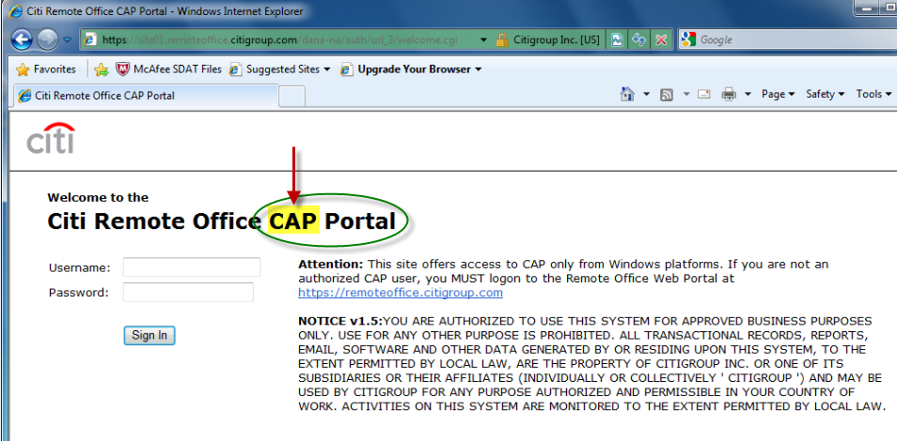

Web Portal:
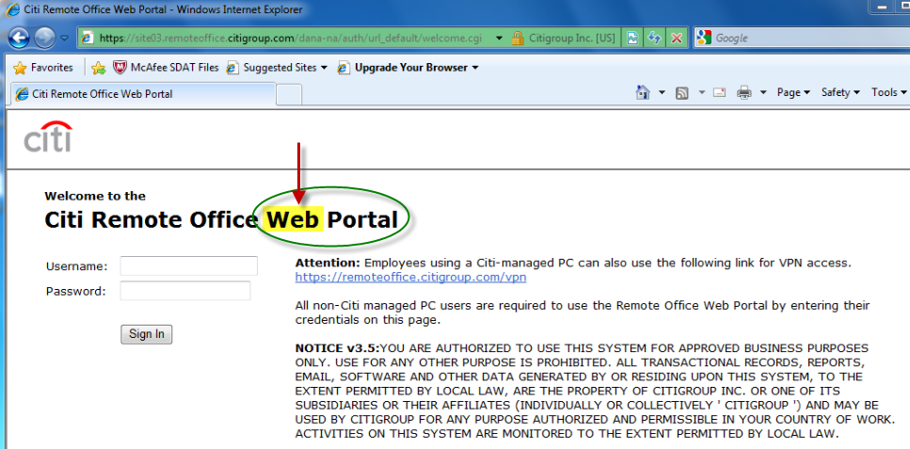

- After logging into the Remote Office CAP Portal, click on “Login to: CAP – NA”
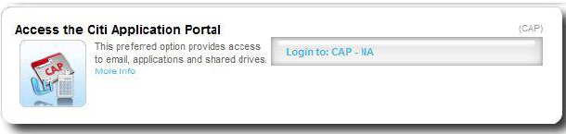

- You will see the following screen.

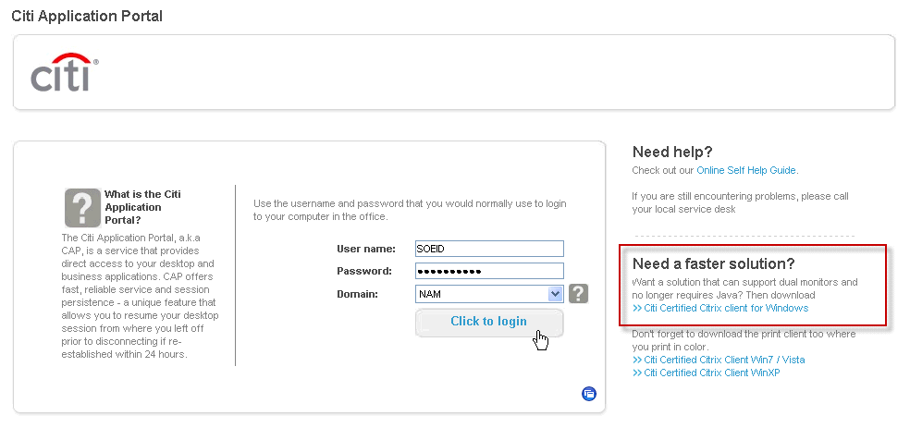

- Download and install the Citrix Web Client/Plug-in on your computer by clicking on the link “Citi Certified Citrix Client for Windows”. (Require that you have local administrator rights on your computer)

- Change the Domain dropdown to the appropriate domain (NAM). Type your domain SOEID and password, and click on “Click to Logon”.
- Once you login, you will get the following screen. Click on “Cap Virtual Desktop”.
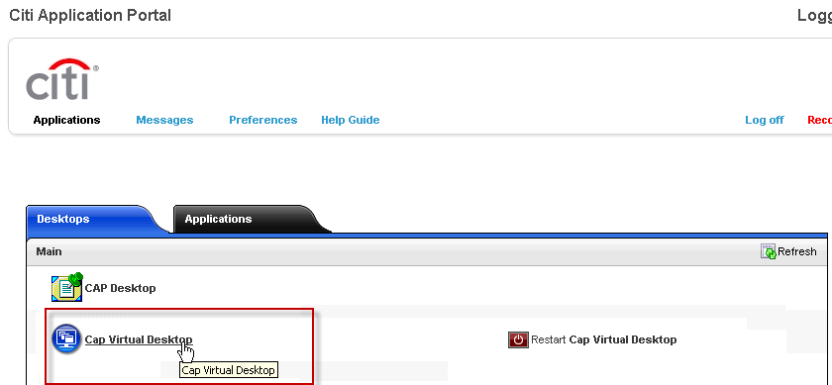
NOTE: You will have option to Restart your VDI by clicking on “Restart CAP Virtual Desktop”.

- You’ll get the following window that says Connecting to your desktop. It’ll take a few seconds before it connects.
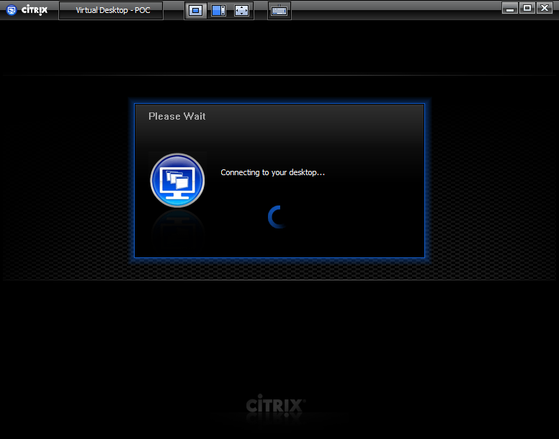

- Once it connects, you will see the Windows 7 or XP Desktop login prompt. Click OK and it will log you in as you normally would to the domain.
